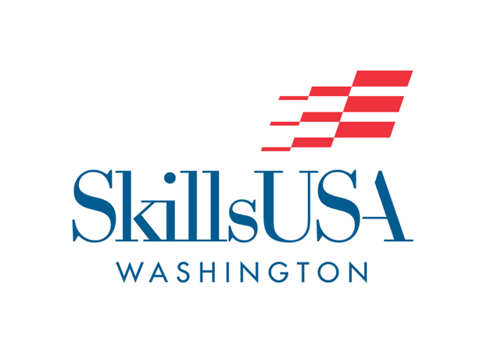
SkillsUSA Washington Code of Conduct Agreement for all members

This document is intended to guide conduct expectations for SkillsUSA
members and chaperones. Members include; Advisors, Students, State
Officers and Chaperones. Violations will be subject to disciplinary action
by appropriate leadership. This may be your local, state or national
advisor, your school district, conference organizers or the SkillsUSA
Washington board of directors.

- Members shall behave in a courteous and professional manner, respecting authority, refraining from language and actions that might bring discredit upon their school, SkillsUSA chapter and SkillsUSA locally, state and nation-wide.

- Members shall participate fully in all appropriate activities, conferences, workshops, business meetings, etc. for which he/she has responsibilities.

- Members shall adhere to the required dress code. Advisors will enforce their student’s dress code at all functions. Failure to follow the dress code at functions may prohibit your participation. During opening and closing sessions, members will forfeit the privilege of being recognized on stage.

- Members must be willing to take and follow instructions as well as provide their name and chapter when asked by those responsible or leading activities.

- Members shall avoid places and actions which in any way could raise questions as to moral character or conduct, both in person and on social media.

- Members shall observe curfew (and lights out) at events and conferences by being in assigned rooms at the times designated in the conference program or agenda. Students are not allowed in rooms of the opposite sex at any time. Students are not allowed in advisor’s rooms.

- No alcoholic beverages and/or controlled substances in any form, shall be possessed by students, advisors or chaperones at any time, under any circumstances. Advisors will be made aware of medications prescribed to students by their physician. Any member found to be under the influence of alcohol or a non prescribed controlled substance will be immediately asked to leave any local, state or national activity at their own expense. In addition, incidents will be reported to his/her school district for follow up.

- SkillsUSA members promote SkillsUSA as a positive student experience; therefore, they will act as a positive role model for students in dress, voice, attitude, actions, and demeanor.

- SkillsUSA Advisors are accountable to and for their students in all SkillsUSA related activities, including sharing schedules and bed checks at curfew.

- SkillsUSA Advisors will follow established guidelines within the organization that protect the rights of all members.

- Social media postings of any nature must adhere to SkillsUSA professional standards and follow the code of conduct and ethics required of all instructors. Postings should not be of a sexual or exploitive nature or be inappropriate for children to see. Postings should not embarrass SkillsUSA if they were viewed by SkillsUSA staff, business partners, board of directors or instructors.

- I have read, and understand the information in this document. I agree to abide by these code of conduct guidelines. In addition to these guidelines, I agree to adhere to the SkillsUSA NLSC Code of Conduct, Photography and Sound Release, Personal Liability and Medical Release included with membership.

In keeping with a tradition of respect for the individuality of our members and our role in workforce development, SkillsUSA strives to ensure inclusive participation in all of our programs, partnerships and employment opportunities. In SkillsUSA, diversity encompasses differences in ethnicity, gender, gender expression and identity, language, age, sexual orientation, religion, socio-economic status, physical and mental ability, thinking styles, experience and education. We strive to make all members, partners and employees feel welcomed and valued in the SkillsUSA family. SkillsUSA believes in treating all people with respect and dignity. We want SkillsUSA to be regarded as a “membership organization of choice” that encourages all individuals to be involved.
Signature: ____________________________ Date: _____________

