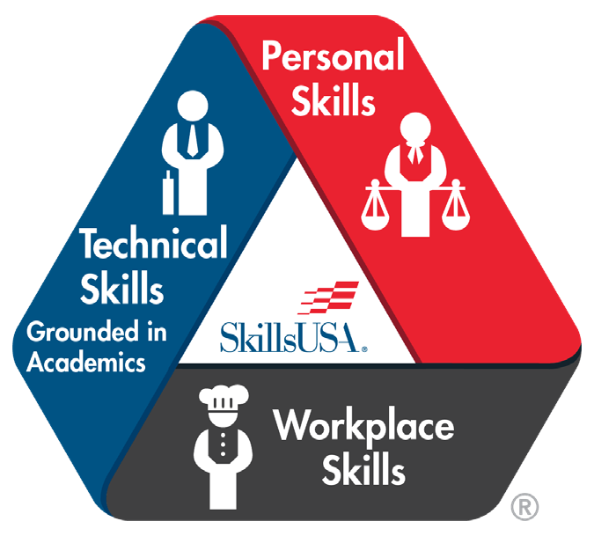

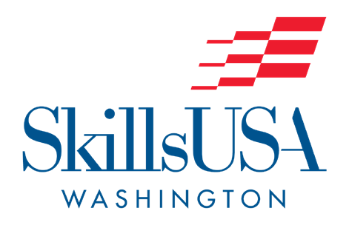

Hotel Murano: $170 single rate, $180 triple, and $190 quad

La Quinta by Wyndham: $136.

**\*Transportation provided for general sessions and events**

$160 for HS members/instructors

$140 for MS members/instructors

$75 observer fee for those attending general sessions ONLY

*$75/person late fee or invoice fee change after March 20

**Websites**

skillsusawashington.org

skillsusa.org

**SkillsUSA State Director**

Karmen Warner

Email: [director@skillsusawashington.org](mailto:director@skillsusawashington.org)

**Delegates**

SkillsUSA is a student run organization, whereby student members are charged with the responsibility of governing the affairs associated with the student constitutions. Participating in the state voting delegate process gives students the opportunity to elect next year’s State Officer Team and impact the direction of the state organization. Ensure you have selected your schools Delegates before registering!

**Contact Information**

Should have invoicing questions please contact Courtney Hutchin at [coordinator@skillsusawashington.org](mailto:coordinator@skillsusawashington.org)

**SkillsUSA Framework**

The SkillsUSA Framework empowers every student to achieve career success. In SkillsUSA and through the SkillsUSA Framework, student members learn and practice skills that are highly sought after by business and industry.

Booking links found at skillsusawashington.org

**Hotel Information:**

Food Truck will be on-site throughout conference. Pre purchase food tickets during registration. Reference agenda below and mobile app for details

Hotel Murano:

* The hotel requires each guest to provide a form of credit of $75 per room per night for incidentals or the room will be set at No Post status.
* Rooms may be paid by cash, credit card or purchase order. Purchase orders MUST be received in advance of arrival to set up direct billing to the P.O. A credit card may be provided at check in or in advance. If it is preferred to provide the card in advance the point of contact is Marilyn Meyer; [Marilyn.meyer@pyramidglobal.com](mailto:Marilyn.meyer@pyramidglobal.com).
* Motorcoach/bus parking must be arranged in advance, also with Marilyn Meyer.

**Conference Registration Cost:**

**Conference Location:**

Opening Ceremonies: Hotel Murano, Tacoma, WA Closing Ceremonies: Hotel Murano, Tacoma, WA Championships: Clover Park Technical College, and Carpenters Union Training Facility

**Conference Date:**

April 13 – 15, 2023

**NEW Food options! Tickets:Food op**

■

■

*SLSC Details*

The SkillsUSA Washington Championships program assesses and recognizes exemplary career and technical education students. These career competitions engage members by testing their skills against standards for entry-level workers in the skilled trades through authentic skill demonstrations. The SkillsUSA Technical Standards are considered the “rule book” of the competitions and outline the competencies assessed.  
The competitions simulate the skills needed to be a professional in the field of their given training program.

The SkillsUSA Championships program connects the work done by students at the local level to the national level. Members must have proven competency at the local and then regional level to advance to the State Championships. At the state competition, student members’ career readiness is evaluated by expert representatives of business, industry and organized labor. The gold medalist of each competition advances on to represent Washington at the National Leadership & Skills Conference held each June in Atlanta, GA.

Through competitions, industry connects with the next generation of their workforce.