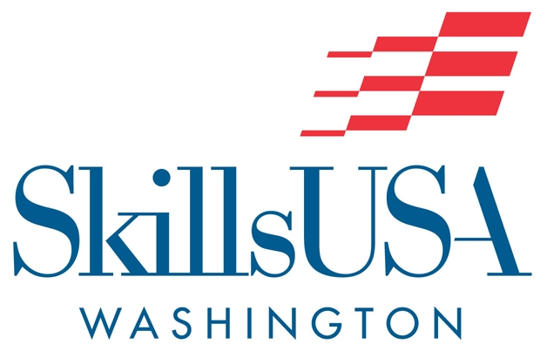

SkillsUSA Fair Play Pledge
It is the intention of this state association and all contest organizers and participants to promote integrity, fair play and respect for all participants within the SkillsUSA Championships national competitions. All Host Teachers must sign this pledge before the contest.
I agree to abide by the principles of SkillsUSA and the Fair Play Code (see below) as set forth by the SkillsUSA Championships.
This commitment to fair play will pave the way for better competitions and positive attitudes.
Fair Play Code:
- I will host a fair contest because I want to, not just because others expect me to.
- In advance, I will make sure that all equipment and facilities are safe and ready for a fair contest.
- I will remember that students need an advisor they can respect.
- I will follow all rules of SkillsUSA and the spirit of fair competition.
- I will do my best to be a true team player.
- I will remember that winning isn’t everything—having fun, improving skill and preparing all students for successful careers are also important.
- I will exclude myself from making any decision that will affect the outcome of the contest.
- I will allow the contest judges to make critical decisions and will not use my power as the Host Teacher to persuade them in any way.
- Once the competition begins, I understand my role will solely be focused on the safety and health of all attendees. I will only interact with the contestant if required to maintain safety.
- I will not interact with my student(s) in any way to provide guidance or direction in the competition, except for when required for safety.

Name of Host Teacher: ____________________________________________________________________

School: ____________________________________________________________________________________

Signature ___________________________________________ Date: __________________

