CHOOSE US BECAUSE YOU BELIEVE IN OUR MISSION:

WHAT’S NEXT?

SUPPORT

OUR

MISSION

VOLUNTEER | Invest your time in running or judging contests. The State Leadership and Skills Conference offers competitive events showcasing the best career and technical education students. The philosophy is to reward students for excellence, to INVOLVE INDUSTRY in directly evaluating student performance and to keep training relevant to employers’ needs. For more information contact Paige Atkins at coordinator@skillsusawashington.org

PROMOTE | As an EXHIBITOR at our Career Fair during the Conference, your business will have the opportunity to interact with 850 of Washington’s brightest students.

GIVE | All funds support SkillsUSA Washington. A quick conversation will determine to what capacity you would like your sponsorship to serve. Call today.

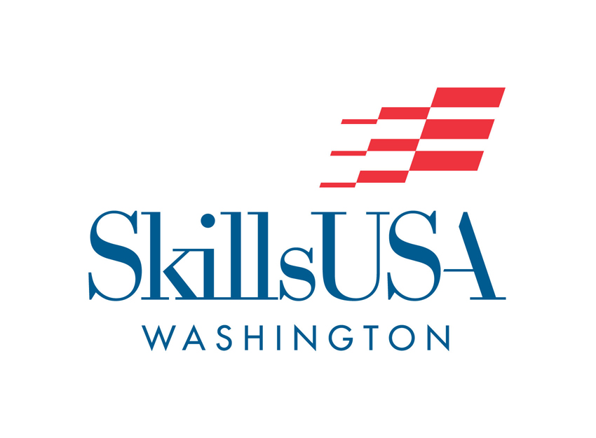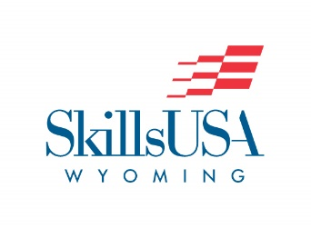

SkillsUSA empowers its members to become world-class workers, leaders, and responsible American citizens. SkillsUSA improves the quality of our nation’s future skilled workforce through the development of Framework skills that include personal, workplace and technical skills grounded in academics.

STATE LEADERSHIP AND SKILLS CONFERENCE | TACOMA, WA
April 13-15th, 2022

SkillsUSA is a national membership association serving high school, college and middle school students who are preparing for careers in trade, technical and skilled service occupations, including health occupations.

We are a partnership of students, teachers and industry ensuring America has the skilled workforce it needs to stay competitive. Your support helps us make this happen.

We know you have many opportunities to give back to your community and our state. Washington SkillsUSA needs your expertise to run safe and relevant contests, and students deserve the opportunity to meet local business and industry partners who are interested in their employable skills.

Financially, we need your support to provide the best and most memorable state conference for our students as well as grow a stronger association that will one day be able to offer scholarship opportunities to its members.

On behalf of the Washington Association of SkillsUSA, thank you in advance for making our organization stronger through your volunteerism and your financial support. I look forward to having a meaningful discussion about what this will look like for you and how we can work together to empower the future workforce of Washington.

Karmen Warner
State Director
director@skillsusawashington.org
skillsusawashington.org
360-608-3826

