SkillsUSA Friday Flash 2.26.21

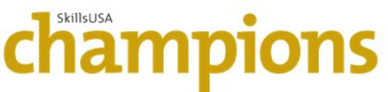
SkillsUSA Membership Deadline is March 1 – Join Now
The SkillsUSA national membership deadline is March 1 each year.Please ensure membership dues are current for all chapter members in order for them to be able to fully participate in all SkillsUSA programs and activities. Visit www.skillsusa-register.org to register yourself and student members. If you need assistance, please contact our Customer Care Team at 844-875-4557 or customercare@skillsusa.org.
SkillsUSA Washington State Leadership and Skills Conference Invitation List
The Invitation list will be available March 2nd. Registration will be available at https://www.skillsusa-register.org/Login.aspx The fee is $100 per student and you must register one advisor from each school – no exceptions. Before you ask about the cost, you need to know we lost so much revenue last year and this year. State and Nationals are the two ways we support our organization. Just like the other CTSOs, our membership is reduced, monies we received from OSPI were reduced 66% and we lost our sponsorship from Boeing. Most of our expenses are fixed. This is a huge financial impact and we are so fortunate to be managing. I hope you will appreciate the savings of no hotel and travel costs, no substitute teachers, etc. The board of directors, myself and our leadership team appreciate your support of your students and SkillsUSA Washington during this challenging time. We need your help to provide this opportunity for our students! Competitions will take place April 17-24th, and the Conference will begin April 26th at 9:00am! A full schedule will be available March 2nd.

SkillsUSA Wahington State Officer ONLINE Application available March 1st. Applicants should have a headshot available and prepare a 2-4 minute speech recorded and submitted by April 1st. Mark your calendar for March 12th 5:00-6:00pm to meet our state officers.
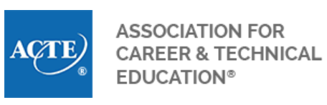
ACTE Offers Virtual Fundraising Webinar March 4
The Association for Career and Technical Education (ACTE) is conducting an “Innovation Through Virtual Fundraising” webinar on March 4 from 3-4 p.m. ET. This webinar — held March 4 from 3-4 p.m. ET — will discuss successful tools and strategies to implement new virtual fundraising efforts. ACTE is working to place career and technical education at the forefront of innovation, including activities that improve the conditions for student learning, teacher practice and other facets of the CTE experience. Prior to COVID-19, many students participated in in-person fundraising opportunities to support student-led activities. With a worldwide pandemic underway, student-supported activities are a challenge to maintain. Please bring your own successful virtual fundraising ideas so all educators can implement effective strategies to support virtual fundraising activities. To register, click here. For further questions, please reach out to Megan Kmiotek at ACTE at mkmiotek@acteonline.org.

Submit Your Chapter Success Stories to be Included in SkillsUSA Champions
As a young automotive technician, Hailey Hedrick already faces one challenge: being a female in a male-dominated industry. Now, she’s also facing the challenge of COVID-19 as she continues working to keep her community ready for the road. Read Hailey’s story on the SkillsUSA Champions digital hub here. The SkillsUSA Champions digital hub is an online publication that includes stories like Hailey’s centering on SkillsUSA members and local chapters across the country. Submit your own news and story ideas through the “Share News and Stories” link at the top of the web page at skillsusachampions.org.
President’s Volunteer Service Award (PVSA) Applications Due by April 1
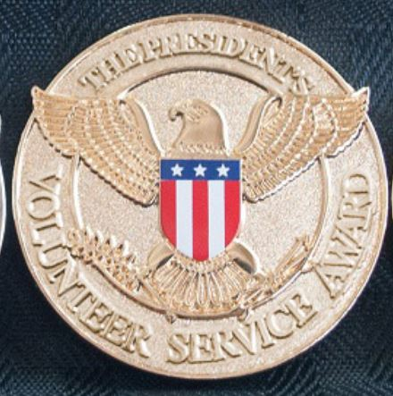
SkillsUSA is a certifying organization for the President’s Volunteer Service Award (PVSA). Recipients can receive an official lapel pin, personalized certificate of achievement, and a congratulatory letter from the president of the United States. To apply for the award, candidates must document their volunteer activities and the number of hours served. This record of service may be a diary, calendar or timesheet with proof of service documented and verified by an agency representative. Candidates must submit a letter of nomination from one of the following: the direct supervisor/agency representative working with the candidate, a school administrator, school SkillsUSA advisor or state SkillsUSA director. Proof of SkillsUSA membership must also be submitted. Candidates must meet the number of hours designated by the President’s Volunteer Service Award to reach the bronze, silver or gold levels of service. Please view application requirements and instructions at: https://www.skillsusa.org/membership-resources/awards/presidents-volunteer-service-award/.

It's the final week of the State of Innovation Challenge - It's time to submit those projects! March 4 is the deadline for project submissions

If you or anyone in your networks is working with young people on the State of Inovation Challenge, please let them know that now is the time to get rolling on their projects and to reach out to us at the project team if they need any assistance or advice.

CTSO competition projects may qualify for this challenge.

Check out the recent press release from Governor Inslee and Superintendent Reykdal about their support for this project.

Thank you for being a part of this effort, Julia Reed, State of Innovation Challenge Project Manager // Kinetic West Tel: +1 202 445 8252
www.kineticwest.com

Regional Coordinator/s needed for 2021-2022 school year for Central Region and Southwest Region, contact tlufkin@comcast.net if interested.

CORE PLUS AEROSPACE INTERSHIP Are you a high school student enrolled in Core Plus Aerospace? Ready to sharpen your manufacturing skills and gain valuable career experience? Apply for Boeing's Summer 2021 Core Plus Aerospace Virtual Internship by February 28! This paid, full-time internship is a great way for students to learn manufacturing and employability skills directly from Boeing professionals – building a foundation for successful entry into manufacturing careers and aligned postsecondary programs in fields like avionics, applied science, engineering, mechatronics, and more. The virtual internship program is tentatively scheduled to run from July 9 to August 6. Take advantage of this internship opportunity to learn more about Boeing, take your manufacturing skills to the next level, and build your resume!
Congratulations to SkillsUSA Washington Design Contest Winner Maria Escobedo
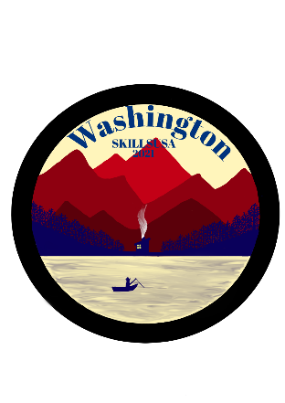 Maria’s design was selected as our state conference pin design! Maria is from Auburn Riverside High School and her advisor is Frank Medina. Well done Maria!

Please remember you cannot reply to this email. If you have questions, my email is below!

Terri Lufkin, tlufkin@comcast.net
Executive Director, SkillsUSA Washington HS & MS
SkillsUSA Hotline: 844-875-4557 customercare@skillsusa.org
360-904-8578

