EVENT Registration, Step –by-step
SkillsUSA Washington State Leadership and Skills Conference Registration is done on the SkillsUSA membership website. This is the same process used for state and national contest registration.

Go to www.skillsusa.org Click Join & login or create a login and password.
Conference - Next register students and advisors under conference. Please remember to select their t-shirt size. You will also need a home address, advisor cell on the day of the event.
Invoice can be printed by going to Conference, then to Fee Summary. Mail in payment & invoice. See end of instructions for information on creating separate invoices.
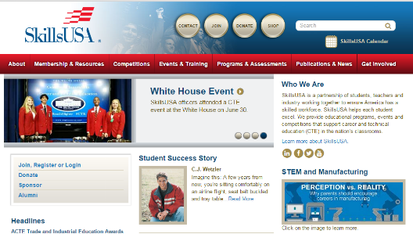
Go to www.skillsusa.org
Click on Join

Log in
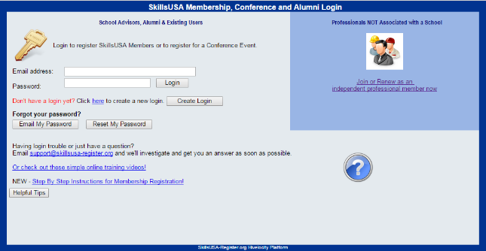

Now Go to Conference

Go to My Registrations

At Filter Event: Go to drop arrow & Choose: SkillsUSA Washington State Leadership and Skills Conference
Go to Add New Registrant

Fill out the form: Advisor, Student or State Officers. No fee for State Officer if not competing.
Please include t-shirt size, home address, gender, teachers cell and emergency contact number for the participant. Save. Repeat for additional participants.

Invoice go to: Conference then Fee Summary and print.
If you want separate invoices for students & advisors, you may do so by entering names, generating your invoice by “submit registration” & then go back and add additional participants.
Please mail in your invoice with your school check/s to: SkillsUSA Washington, Attn: Terri Lufkin, PO BOX 2698, Olympia, WA 98507

