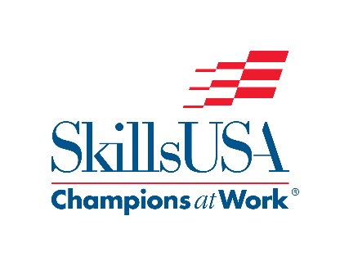

Auto Refinishing Paint Rotation

YEAR |  | COLOR TINTING  WET EXERSICE | SPOT REPAIR | FEATHEREDGE PRIME & BLOCK
2019 |  | Sherwin Williams | PPG | BASF
2020 |  | BASF | Sherwin Williams | Akzo Nobel

