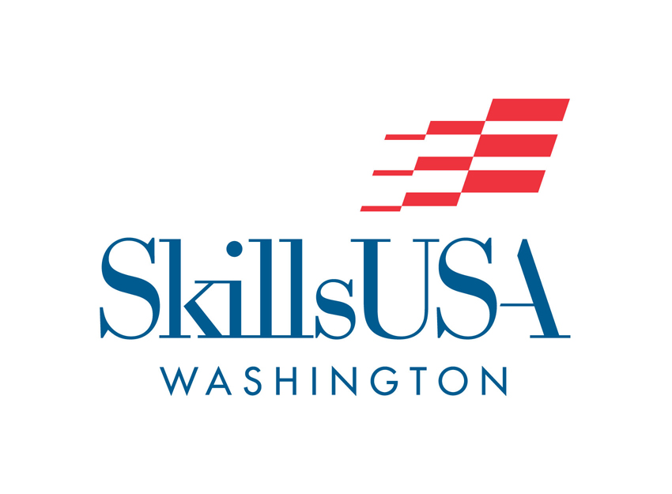
SkillsUSA Washington
State Leadership &
Skills Conference

March 31 – April 2, 2016
Tacoma, Washington

Registration Packet

SkillsUSA Washington Leadership & Skills Conference
Please check the appropriate boxes as you complete the registration process. This will insure proper registration of your chapter’s delegation at the State Conference

Action Due Date

Conference Invite:
Received State Conference registration packet and Invitation List from February 22, 2016
SkillsUSA Washington. List available @ www.skillsusawashington.org.

Hotel Reservations:
Book hotel reservations with the approved conference hotels. March 11, 2016
Submit a rooming list to the hotel.

Registration & Competitive Event Application: March 11, 2016
All registrations must be completed at: www.skillsusa-register.org for everyone
attending SkillsUSA Washington Leadership and Skills Conference. Please make sure you include all information. Registration will be available February 20, 2016.

NLSC Form 1:
Have the “NLSC Form 1” signed for each student. March 11, 2016
This form is a liability release. Enter information for this form at www.skillsusa-register.org

Advisor Acknowledgement Form:
Send to: tlufkin@comcast.net or mail to: March 11, 2016
SkillsUSA Washington, P.O. Box 2698, Olympia, WA 98507. You may fax this form
to 360.586.9321.

State Officer Candidate & Courtesy Corp Applications:
Send to: tlufkin@comcast.net or mail to: March 11, 2016
SkillsUSA Washington, P.O. Box 2698, Olympia, WA 98507. Applications are enclosed in packet.

Registration Materials:
I will pick-up my registration packet at conference check-in (Hotel March 31, 2016
Murano) April 2, 201 between 12:00 & 3:00 PM. Please have one advisor
Per school pick up packets. Students are not allowed to pick up registration packets.

Resume Submission:
Each contestant is required to submit a one page resume at each March 31- 4/2 2016
contest. Submit resumes to contest host or judges and at job application.

National SkillsUSA Leadership & Skills Conference
Registration Deadline: April 22, 2016
The NLSC “Nationals Declarations Form” and information packet will be given to
Contestants immediately following the announcement of medalists.

SkillsUSA Washington State Leadership and Skills Conference – 2016 Tentative Schedule
Thursday, March 31 – Hotel Murano, Tacoma, WA
- Noon-3pm CHECK-IN One Advisor per school, no students
Confirm contest times
SkillsUSA Professional Test - Required
Turn in Application for Job Interview & Employment Application Process contests
- Noon-3pm New Advisor Training – contact dennis.wallace@k12.wa.us
- 3:00-5:00 OPENING Session
- 5:00-8:00pm SkillsUSA Store
Conference Registration Continued
SkillsUSA Professional Test – Required
Turn in Application for Job Interview & Employment Application
Process contests
- 6:30-7:30 Technical Contest Orientations (not finalized)
- 7:00-10pm Quiz Bowl Rounds 1 & 2 and Health Knowledge Bowl
- 11:00 pm Curfew
Friday, April 1
- 6:45-7:00am Busses to Technical Contests
- 8:00-1:00pm Technical Contests
- 9:00-1:00pm Advisor Training Workshops
- 12:00-1:30pm Leadership Judges Orientation and lunch
- 12:00-1:00 SET UP: Chapter Displays, Promotional Bulletin Board & Notebooks
- 12:00-2:00 Lunches: Contest Sites & Murano
- 12:00-6:00 Medical Math, Medical Terminology, SkillsUSA Professional Test
- 2:00-6:00pm Leadership Contests
- 6:00-7:30pm State Officer Candidate Interviews
- 6:30-7:00pm PICK UP: Chapter Displays, Promotional Bulletin Board & Notebooks
- 8:00-10:30 Social Activity
- 11:00 pm Curfew
Saturday, April 2
- 7:00-9:00 am Advisor Breakfast & Regional Meetings
- 8:00-11:00 am Community Service Project
- 8:00-10:00 am FINALS – Job Interview FINALS – Job Skills Demo ‘A’
- 9:30-11:30 am State Delegate Meeting & Elections
- 9:00-1:00 pm Advisor Training Workshops (see program for all choices)
- 1:00-3:00pm Closing Awards Ceremony
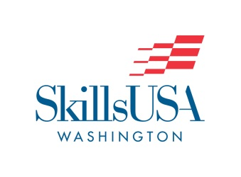
February 17, 2016

TO: SkillsUSA Washington Advisors

FROM: Terri Lufkin, Executive Director

RE: 2016 SkillsUSA Washington State Leadership & Skills Conference (SLSC)

Please read this registration packet carefully. Changes take place annually. Do not rely on
previous experience for registration procedures.

SkillsUSA Washington members are invited to Tacoma, Washington this year for the annual State Leadership & Skills Conference. Your contest host this year is Bates Technical College.

This letter contains information all participants at the State Leadership & Skills Conference (SLSC) will need. Please follow the instructions and meet all deadlines! Your cooperation is appreciated.

Registration Deadline – March 11, 2016

REGISTRATION:
Registration fee is $100 for all contestants, advisors and chaperones. Registration for Courtesy Corp and observers will be $60. Make checks/purchase orders payable to SkillsUSA Washington. Purchase order or payment must be on file with the SkillsUSA Washington Office prior to picking up your schools contest materials at check-in. Registration fees are non-refundable.

The registration fee includes conference contest materials, insurance, workshops, transportation (assigned times and locations & only to conference hotels), Friday night activities and Friday lunch. Lodging, personal expenses and all other meals are your responsibility.

You will be able to register from the SkillsUSA.org website by Friday, February 20th. This is the same site utilized for SkillsUSA national registration/membership. There is a 7 minute you tube video to help!

Conference registration packets will be available for advisors to pick-up at Conference Check-In at the Hotel Murano Pavilion Thursday, March 31 from 12:00 – 3:00 PM and from 5:00 – 8:00 PM. Students will not be allowed to pick-up conference materials or be in the check-in area. Registration materials will only be released when “Advisor Acknowledgement Form” and final payment or purchase order are received. Contestant numbers and name badges will be provided in registration materials.
Online registration, payment or purchase order and the Advisor’s Acknowledgement Form are to be postmarked by March 11, 2016, and must be sent to SkillsUSA Washington, P.O. Box 2698, Olympia, WA 98507.

If your payment and your Advisor Acknowledgement form are not postmarked by March 11, we will assume your students will not be attending or competing and they will be dropped from the contestant list. Please notify Terri Lufkin at tlufkin@comcast.net or at: (360) 904-8578 as soon as possible if you know a student is not going to compete.

CONTESTANT RESUMES:
All contestants must submit a typed one-page resume at each contest. Give resumes directly to the contest judges or host at their contest time. Students who do not submit a one-page typed resume will be deducted the points possible from the contestant’s final score.

HOTEL ACCOMODATIONS:
SkillsUSA Washington will be using the following approved hotels (these are the ONLY approved conference hotels). All participants requiring lodging must stay at an approved conference hotel. All reservations must be made by contacting the hotel directly and stating you are with SkillsUSA. All reservations are subject to availability. Please be sure to get your purchase order completed so you can bring a check with you to the conference or have the check mailed immediately following the conference. If you need further information regarding hotel accommodations, contact the SkillsUSA Washington Office.

Hotel Murano Courtyard by Marriott
1320 Broadway Plaza 1515 Commerce Street
Tacoma, WA 98402 Tacoma, WA 98402
(253) 238-8000 (253) 591-9100
(888) 862-3255 (800) 321-2211
Rates: $132.00-$152 + tax Rates: $144.00 + Tax
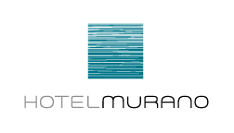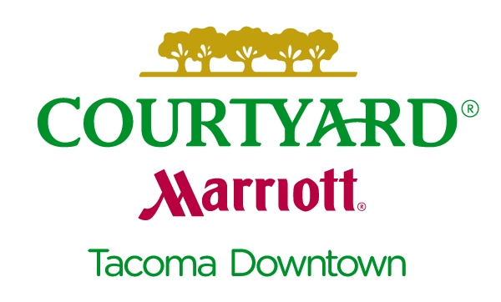

Please note that a complimentary breakfast is not included in the rate.

Official check in time is 3:00pm, Check out time is 11:00am.

Guest Parking Marriott is $10 / $16 at Hotel Murano. Complimentary daytime parking is available at the Tacoma Dome Station and guests can ride the Tacoma Light Link Rail (complimentary) @ Commerce and 15th Street.

WASHINGTON STATE LEADERSHIP & SKILLS CONFERENCE (SLSC):
Posted on the SkillsUSA Washington Website is the list of eligible contestants for the WSLSC called “Washington State Leadership & Skills Conference Invitation List.” This is located under events and “slide right” after you scroll down to WA State Conference. This list is also available through Regional Coordinators. Contestant eligibility is determined by a formula outlined in the SkillsUSA Washington Policies and Procedures guidelines. Contestants are listed by contest, region, name, and school. Should an eligible contestant withdraw from a contest, an alternate from that region will be chosen and allowed to compete. The number of positions may vary in several contests due to equipment, work stations, and space. State competition is for the most qualified. Alternates are listed for all contests, designated by the word “Alternate,” to assist in your conference registration. Alternates must be members and properly registered for the conference to compete if there is a “no show.” Please notify the SkillsUSA Washington office at (360) 904-8578 or tlufkin@comcast.net before March 11, 2016 with any contest withdrawals.

Review Technical Standards with your contestants prior to the SkillsUSA State Championships. If you need a copy of the Technical Standards, contact your advisor, regional coordinator or SkillsUSA Washington office.

Regarding State Level Contests, individuals may participate in more than one contest. A student may compete in up to three contests. (1) Technical Science Contest and either (2) Leadership Development Contests or (2) Occupationally Related Contests. If not participating in a Skill Contest, individuals may participate in a combination of 3 leadership and occupationally related contests. Individuals may participate in only one Technical Contest.
At National, students are limited to one contest in any of the above categories.

LEADERSHIP CONTEST ANNOUNCEMENTS:
Notebooks must be dropped off Thursday- locatation TBD. Notebooks will be evaluated by a panel of judges. Notebooks that have not completed 80% of requirements will not be allowed to compete on Friday. Promotional Bulletin Boards & Chapter Displays are to be set-up in their designated room on Friday, April 1st. Chapter Displays, Promotional Bulletin Boards, and Notebooks must be picked up by 7:00 PM Friday, April 1.

LEADERSHIP/OCCUPATIONAL CONTESTANT TIMES:
On March 31st, once advisors receive conference registration materials, it is their responsibility to give Leadership Contestants their contest times. These contest times have been pre-assigned.

DONATIONS & PRIZES:
SkillsUSA Washington solicits prizes and donations for contest areas. Local advisors and interested persons are encouraged to solicit prizes and donations for presentation to contestants at the Awards Program. Contact tlufkin@comcast.net for a current sponsorship form.

SKILLSUSA WASHINGTON PROFESSIONAL TEST & REQUIRED ID:
The SkillsUSA Washington Professional Test will be administered at the Hotel Murano from noon-3pm and 5:00-8:00 PM on Thursday, March 31, 2016 and Noon-6pm Friday, April 1st. The test is not available on-line. All contestants and State Officer Candidates must take the SkillsUSA Professional Test. This test will be used as a tie breaker for all contests. We prefer the professional test be taken prior to competitions on April 1 but the test may be taken April 1 by 6pm. Questions from the test are taken from the Leadership Handbook and PDP Levels 1 & 2, which can be purchased from National SkillsUSA.

All contestants must have proof of identity (Picture ID) to check-in for competition. Suggested types are valid driver’s license, Washington State Identification Card, ASB card, or valid passport. ID will be required at contest sites before sign-in. Students not having ID must have two SkillsUSA advisors verify their identity to the contest host. To avoid problems, please have your students arrange to bring their identification and carry it with them at all times.

SkillsUSA Technical Skills Contest Written Tests:
Technical Skills Contests will have their written test during the contest unless otherwise stated during contest orientation.

EQUIPMENT AND BUSSING: If you plan to carry equipment on busses from the hotel to the contest site that is not contained in your seat, please notify tlufkin@comcast.net so this can be shared with transportation coordinator and busses with storage made available where needed.

DELEGATE ASSEMBLIES & VOTING DELEGATES:
Delegates from each SkillsUSA Chapter will meet 9:00-11:00 AM on Saturday, April 2nd. State Officer Candidates will be introduced and campaign speeches given. State delegates will discuss upcoming activities and constitutional amendments.

We will be electing state officers for next year’s State Officer Team on an open State Ballot. Each region is entitled to two officers on the State Officer Team (total of ten officers). All State Officer Candidate Application Forms, letters of recommendation and school transcripts are to be sent to the SkillsUSA Washington Office by March 31, 2016. The 2015-16 State Officer Application can be downloaded from the SkillsUSA Washington Website.

Each chartered school will have 2 delegates plus one for each 50 active members above the first 50, plus one for 100 percent of the total possible membership. Please select your voting delegates prior to the conference and prepare them for participation in their State Delegate Meeting. Voting delegates will be identified by a ribbon attached to their name badges. Submissions to the agenda for the State Delegate Session must be made in writing and sent to the State Executive Director. Revisions or amendments to the State Constitution must be submitted to the SkillsUSA Washington State Office prior to the State Conference.

NATIONAL LEADERSHIP CONFERENCE & SKILLSUSA CHAMPIONSHIPS:
The SkillsUSA Conference is in Louisville, Kentucky, June 20-24, 2016. Information will be available at the State Conference. All participants attending Nationals need to register online by May 2, 2016 at www.skillsusa.org. All inquiries should be directed to SkillsUSA Washington at: tlufkin@comcast.net.

DRESS CODE:
Be sure to read the following dress code requirements. All students and advisors are to be in official dress or the specified option at opening session, delegate meetings, workshops and awards ceremony. Anyone not wearing required dress will not be allowed entrance to events listed above. SkillsUSA Washington Polo Shirts are allowed as Official Dress in Washington State only. Polos may be purchased at the conference, sizes and colors limited.

Check the dress requirements for specific contests so your students will not be penalized. Activity Night Dress Code: Advisors please review the code of conduct and appropriate dress for activity night. Students dressed inappropriately will be asked to change.

Women - Students & Advisors
Official Dress: White blouse, SkillsUSA polo shirt, SkillsUSA blazer or Washington or National jacket/sweater, black Carhartt jacket; black skirt/slacks; black sheer or skin-tone seamless nylons; black dress flats or heels. Specified Option: Those who do not possess official dress shall wear a solid color dress, skirt/slacks, and blouse or sweater and dress shoes.

Men - Students & Advisors
Official Dress: White shirts, SkillsUSA polo shirt, black solid tie, SkillsUSA blazer or Washington/ National jackets/sweater, black Carhartt jacket, black slacks, black socks, black dress shoes. Specified Option: Solid color button shirt and tie, solid color slacks and belt, dress sock and dress shoes. Jacket optional.

Unless otherwise specified, ONLY approved attire will be worn at official functions. Skills contest attire shall be worn at other functions. The objective of the SkillsUSA dress standards is to project a sharp, professional image to business, industry, and the general public. Each advisor and student has a responsibility to project the best image possible.

Hats are not to be worn during an official meeting or with official dress. Jeans, cutoffs, tank tops, inappropriate t-shirts or revealing clothing shall not be worn at SkillsUSA activities and will cause you to be turned away at the door.

ADVISOR BREAKFAST MEETING:
An Advisor Breakfast Meeting will be held Saturday, April 1st, 7:00 AM at Hotel Murano. Please attend this meeting as important association information will be discussed. Advisors who haves items for the agenda should contact SkillsUSA Washington at (360) 904-8578 or tlufkin@comcast.net and add agenda items. Regional advisor meetings are scheduled in the same room right after the Advisor Meeting. Contact your Regional Coordinator to have regional items put on the agenda.

STATE COURTESY CORP:
Enclosed with this registration packet is an application form for those students interested in being a part of the SkillsUSA Washington State Courtesy Corp. Courtesy Corp students will assist state officers and conference staff at information booths, as runners for contests, workers in headquarters, etc. If you have students interested, please have them fill out the enclosed application and mail to SkillsUSA Washington by March 11, 2016.

ADVISOR OF THE YEAR NOMINATION:
SkillsUSA Washington is taking nominations for Advisor of the Year. If you know an advisor that should be nominated to represent your region and possibly Washington at Nationals, please fill out the nomination form found at the SkillsUSA Washington website: www.skillsusawashington.org. Nominations can be submitted by students and/or advisors. Nominations are due by March 14, 2016.

ADVISOR ACKNOWLEDGEMENT FORM
THIS PAGE IS TO BE INITIALED IN EACH SPACE, THEN SIGNED & RETURNED NO LATER THAN MARCH 11, 2016

______ I understand that there will be no changes or refunds for changes made after March 11, 2016, to my registration.

______ I understand there is a $5 charge for any lost or misplaced name badge. Your school will receive a bill after the conference for each name badge requested.

______ I understand if my student fails to pick up his/her medal(s) or prize(s) and wishes to receive them, the student will be responsible for shipping/handling charges associated with the items, payable prior to shipping.

______ I understand my registration must be submitted by March 11, 2016.

______ I understand the SkillsUSA Professional test will serve as a tie breaker in all contests. Tests will be administered Thursday noon-3, 5-8pm & Friday noon-4pm.

______ I understand any grievances must be filed with the State Office within one (1) hour of the end of the contest. Grievances filed after that time will not be reviewed.

______ I understand that tool lists are posted on the SkillsUSA Washington web site, and will not be sent to individual schools. National lists will be used unless otherwise noted, and the website will be updated on a regular basis.

______ I affirm I have read and explained “Code of Conduct” and “Dress Standards” with my students and that I will be notified if a student is not adhering to the standards.

______ My chapter members participating in the SkillsUSA Washington Leadership and Skills Conference agree to abide by the rules. I have had each student and the respective parent/guardian sign the consent form (NLSC Form 1).

______ As a role model/advisor, I agree to set a positive example for my students.

I further understand that as an advisor, I accept responsibility for the supervision of my students at all times.

___________________________________ _______________________________________
Advisor Signature / Advisor Name Principal/Vocational Director Signature

__________________________________________________________________________________
School Name School Address School Phone

Please Note: Reference WAC 180-44-060 Teachers using habit forming drugs (without valid prescriptions) or use of alcoholic beverages on school premises or at school-sponsored activities off school premises shall constitute sufficient cause for dismissal or non-renewal of contract.

Send to: SkillsUSA Washington, PO Box 2698, Olympia, WA 98507. Postmark Date: March 11, 2016

SkillsUSA STATE CONFERENCE
ADVISOR/CHAPERONE RESPONSIBILITIES

- Advisors are to make sure all students abide by the rules, practices, and procedures of the SkillsUSA organization.

- Advisors will be informed and responsible for the activities and whereabouts of their students at all times.

- Advisors shall stay at the designated hotel while attending the conference with students.

- Advisors are not permitted in bars, night clubs, etc.

- No alcohol or illegal drugs in any form shall be possessed by advisors at any time or under any circumstances.

- Advisors shall be registered and shall attend the workshops, committee meetings, etc., unless specifically excused.

- Curfew, as shown on the agenda, shall be absolutely enforced by each advisor.

- There will be no smoking by advisors in the presence of students, during the general sessions, official business and banquets.

- Advisors will conduct themselves in a professional manner and maintain a neat and well-groomed appearance.

- Leaving the conference prior to the conclusion will only occur in case of emergency.

- Rule infractions by any student(s), observed by advisors (regardless of program), shall be handled as if the student(s) were a part of that advisor’s program.

- Anytime advisors are working with a student or students in a hotel room, the door must remain open.

- Advisors should check student rooms before check out.

SkillsUSA Washington Conference Code of Conduct
The sponsoring school district is responsible for the conduct, safety, welfare, and liabilities incurred by students attending SkillsUSA activities. The following are designed to protect the interests of all parties involved in SkillsUSA activities.

- The term ”conference participant” shall mean any SkillsUSA student member and/or attendee at a state leadership conference or workshop.
- Conference participants shall abide by rules, practices, and procedures of SkillsUSA Washington at all times. From the time they leave home until the time they return home.
- Conference participants shall keep their adult advisors informed of their activities and whereabouts at all times.
- Conference participants shall stay at the designated hotel, not with friends or relatives, while attending the conference; except that the participants from the host city may be assigned to their accommodations by their school district advisor.
- Conference participants shall not use their own car(s) or ride in cars belonging to others during the conference unless authorized by their school district or advisor.
- Only conference participants shall be in attendance at the conference and related program activities.
- Conference participants are not permitted in bars, night clubs, etc.
- No alcohol or illegal drugs in any form shall be possessed by conference participants at any time under any circumstances.
- Conference participants shall respect and abide by the authority vested in the Executive Council, advisors and other authorized conference representatives.
- All conference participants shall be registered and shall attend the workshop, contest, committee meetings, etc. for which they are registered, and shall attend all scheduled business sessions and other activities unless specifically excused by their director.
- Curfew, as shown in the agenda, shall be absolutely enforced by each chapter’s advisor.
- Conference participants will not be allowed in the rooms assigned to the opposite sex unless accompanied by an official conference advisor or room door is visibly open.
- There will be no use of tobacco products during general sessions, official business sessions, or banquets.
- Conference participants violating and ignoring any of the above rules may subject their entire delegation to being unseated, its candidates being disqualified, and any honors or offices being cancelled and withdrawn from members of the delegation, and the entire delegation being sent home. Rule infractions will be acted upon by the SkillsUSA Washington Board of Corporate Officers.
- Conference participants will conduct themselves in a professional manner and maintain a neat and well-groomed appearance. The SkillsUSA Washington Board of Corporate Officers is empowered to request participants to conform to the high standard of SkillsUSA or remove themselves from the conference.
- The cost of defacing any public or private property will be assumed by the participating individual(s) or associated chapter.

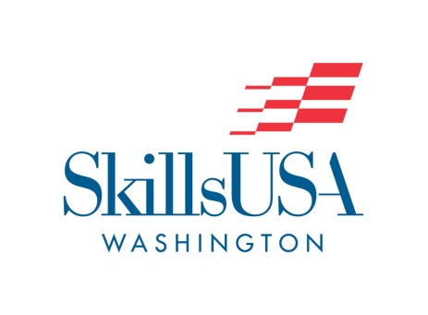

WELCOME!
Future Leaders Ahead

SkillsUSA Courtesy Corps 2016
What is Courtesy Corps?
Volunteer students, like you, who come to the state leadership conference and help keep the conference running smoothly. This includes: setup and tear down of ceremonies, ushering at the ceremonies, helping with workshops, and helping with competitions.

Why should I participate in Courtesy Corps?
Courtesy Corps is a good opportunity to start your path into leadership or even to fine tune your leadership skills. Participating in the Courtesy Corps is also a good way to receive community service hours (which look great on college scholarship applications). You will also receive perks such as a reduced registration fee if not competing in a competition as well as recognition for your hard work.

For more information, contact SkillsUSA Washington.
Office Phone: (360) 904-8578
tlufkin@comcast.net

Future Leaders Ahead!
SkillsUSA Courtesy Corps 2016

I grant permission for __________________________________ to participate in the State SkillsUSA Washington Conference as a Courtesy Corps participant.

___________________________________________________
Signature of Parent or Guardian

I recommend this applicant serve on the SkillsUSA Washington Courtesy Corps for the SkillsUSA Washington Leadership Conference.

___________________________________________________
Signature of SkillsUSA Advisor

I have read the requirements and duties of a SkillsUSA Washington Courtesy Corps member and believe myself to be qualified. I will abide by the rules set by SkillsUSA Washington governing my conduct.

________________________________________ ____________________________
Signature of Applicant Date

Application should be forwarded and questions addressed to:

SkillsUSA Washington
Courtesy Corps Committee
P.O. Box 2698, Olympia, WA 98507
Phone: (360) 904-8578 Fax: (360) 586-9321 Email: tlufkin@comcast.net

Application for SkillsUSA Washington Courtesy Corps

Student Information:

Name: _____________________________________________________________________

School: _____________________________________________________________________

Home Phone: _________________________ Region: _______________________________

Home Address : ______________________________________________________________

City: _______________________________ State: WA Zip: __________________

Shirt Size: ________ (Small, Medium, Large or X-Large)

Why do you want to attend the SkillsUSA Washington Leadership & Skills Conference and serve as a Courtesy Corps member?

___________________________________________________________________________

___________________________________________________________________________

___________________________________________________________________________

Number of years in SkillsUSA: _______________

Will you compete in any competitions at State and what are they (if any)?

___________________________________________________________________________

Have you attended a State Conference before: Yes ____ No ____

Qualifications for Courtesy Corps:
- Individuals must be willing to work and help create a successful conference.
- Must receive signed recommendation and support from SkillsUSA advisor.
- Individuals must complete the official application form for nomination and obtain the signatures of a parent or guardian and SkillsUSA advisor.
- Must be available to participate throughout the duration of the conference. .

